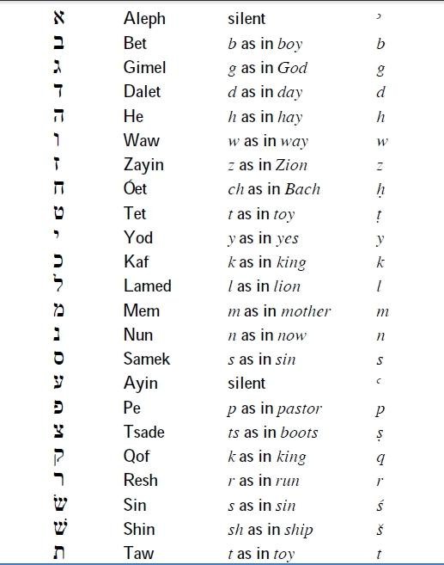
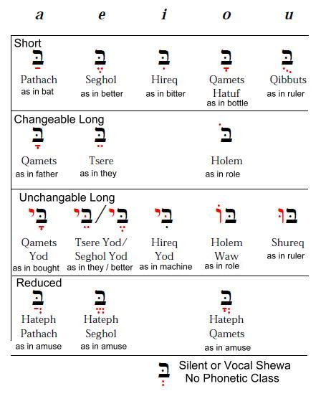

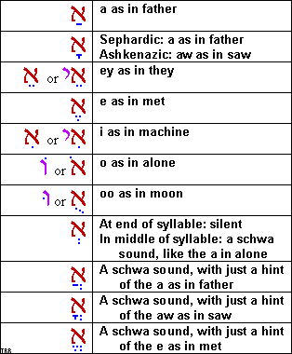

Biblical Hebrew Study Group
Chapter 1 and 2 Crib Sheet

Learn to read Biblical Hebrew this year !
To Join Contact PastorRice@GSBaptistChurch.com



